53

Aligning With Learning Standards
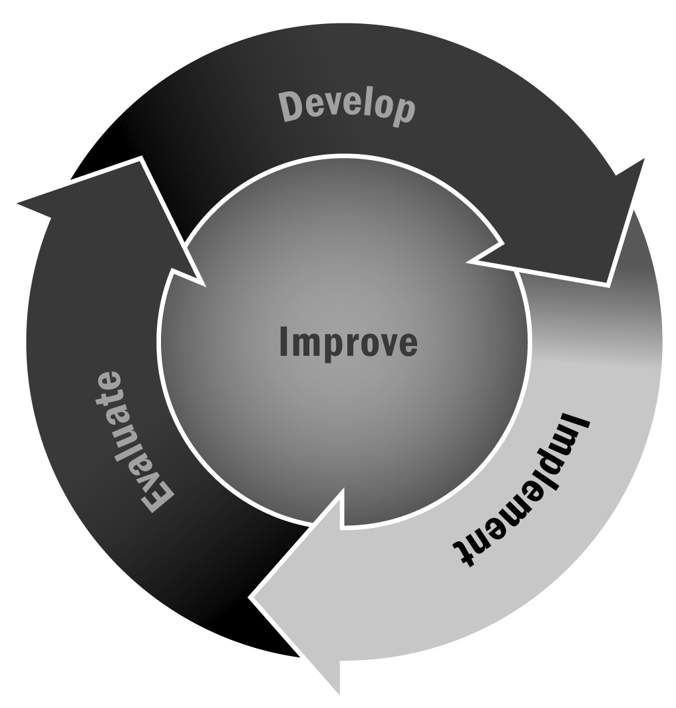
In Chapters 3 and 4, you learned about the importance of aligning activities with local and state learning standards and the Common Core State Standards. Intentionally integrating learning standards into activities supports learning and youth development.
Directions: Use or adapt this worksheet to ensure your activities and lessons align with learning standards. You may use this tool in conjunction with Tool 73: Intentional Activities to develop and implement learning components in every program activity or project. Staff should also reference the Common Core State Standards for Mathematics and English Language Arts in addition to other state learning standards by visiting their local department of education website.

Standards Alignment Worksheet – Example
Component | Instructions | Example
Name of activity |  | Cooking Club – “Being a Vegetarian” activity
Grade level |  | Fifth and sixth grades
Description of activity | Identify the purpose and goals of the activity as well as how youth will meet those goals. What will youth learn as a result of this activity? What skills will they develop? How will they do that? | - This club focuses on reinforcing and improving the math and science skills of participants in the program through cooking. The club aims not only to develop the learning of participants but also to develop a deep appreciation of a healthy diet and lifestyle.  - In this activity, youth will first learn what it means to be a vegetarian by reading a magazine article. They will discuss what vegetarians do and do not eat in small groups and will brainstorm possible breakfast, lunch, and dinner options. Next, youth will work in small groups to prepare a vegetarian meal. Finally, youth will enjoy the meal they have made together.
List the learning standards that are integrated into this activity/project | A helpful first step is to identify the subject that this activity most likely aligns with. Next, locate the standards for the grade level of youth served in the content area you have identified. Think about the description and what you think youth will learn from this activity, and find standards that match or align. | - Determine the meaning of words and phrases as they are used in a text, including figurative, connotative, and technical meanings (CCLS for Informational Text 6–12).  - Read and interpret a variety of math-related concepts (CCLS Math 5–6).  - Engage effectively in a range of collaborative discussions (one on one, in groups, and teacher led) with diverse partners (CCLS for Informational Text K–5).
Are there opportunities to integrate skills or competencies (e.g., leadership, group work, critical thinking) or other “embedded” learning (e.g., applied learning, exposure to new topics, themes, or vocabulary) into this activity? | Are there other skills that youth will have the opportunity to develop as a result of participating in this activity? Think about how the activity will flow—how youth will interact with their peers or with the materials. Are there other related topics that you can integrate into this activity that will enrich the learning experience? | - Budgeting and managing money  - Applied chemistry (e.g., cooking temperature, pesticides, herbicides)  - Applied biology (e.g., plant and pest classification)  - Planning and making healthy choices  - Team building via community dinners

Standards Alignment Worksheet – Template
Component | Instructions | Example
Name of activity
Grade level
Description of activity | Identify the purpose and goals of the activity as well as how youth will meet those goals. What will youth learn as a result of this activity? What skills will they develop? How will they do that?
List the learning standards that are integrated into this activity/project | A helpful first step is to identify the subject that this activity most likely aligns with. Next, locate the standards for the grade level of youth served in the content area you have identified. Think about the description and what you think youth will learn from this activity, and find standards that match or align.
Are there opportunities to integrate skills or competencies (e.g., leadership, group work, critical thinking) or other “embedded” learning (e.g., applied learning, exposure to new topics, themes, or vocabulary) into this activity? | Are there other skills that youth will have the opportunity to develop as a result of participating in this activity? Think about how the activity will flow—how youth will interact with their peers or with the materials. Are there other related topics that you can integrate into this activity that will enrich the learning experience?

